**TEST REPORT**

Calculator App (Android)

Document Version:1.0

**Version history**

|  |  |  |  |
| --- | --- | --- | --- |
| Version number | Date | Edited by | Comments and changes |
| 1.0 | 26.10.2018 | V.Shevchenko | First version |

**Table of Contents**

1. INTRODUCTION
   * + - 1. Purpose
2. TEST SUMMARY
   1. Overall information
   2. Functional tests
   3. External factors tests
   4. UI/UX tests
   5. Localization & translation tests
   6. Performance tests
3. TEST RESULTS & ASSESTMENTS
   1. Test results
   2. Assessments
4. CONCLUSION

**1. INTRODUCTION**

**a. Purpose**

This document is the software test report of the Android default Calculator app. It contains summary and results of tests, which were executed during testing stage.   
We are testing app version 7.5 (build 213680574). Application was installed as in-stock app and was updated to current version via Play Store. It’s a Native Android app.

**2. TEST SUMMARY**

**a Overall information**

**Project name:** *Calculator*

**Project version***: 7.5 (build 213680574)*

**System version:** *8.0.0 (OPXS27.109-34-15)*

**Device:** *Moto Z2 (XT1789-06)*

**Testing period:** *26-10-2018 - 27-10-2018*

*More information about device is provided in screenshots below:*

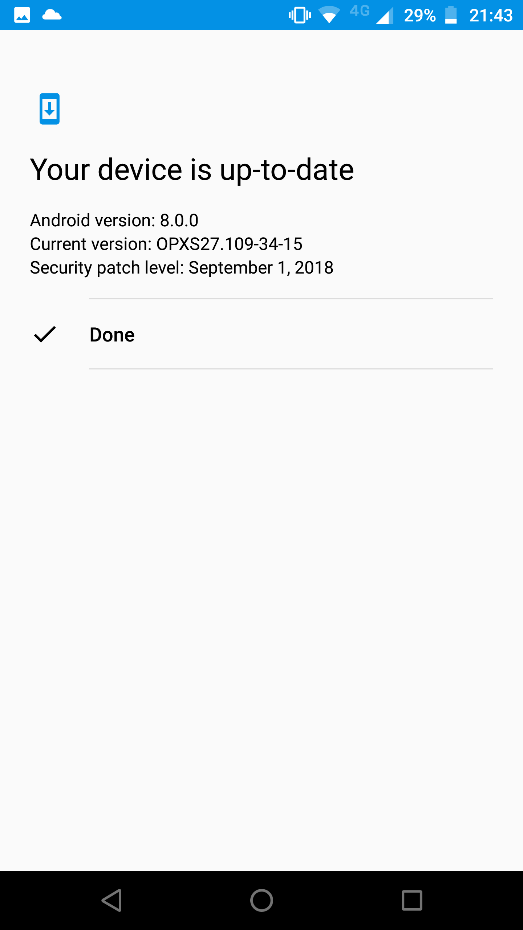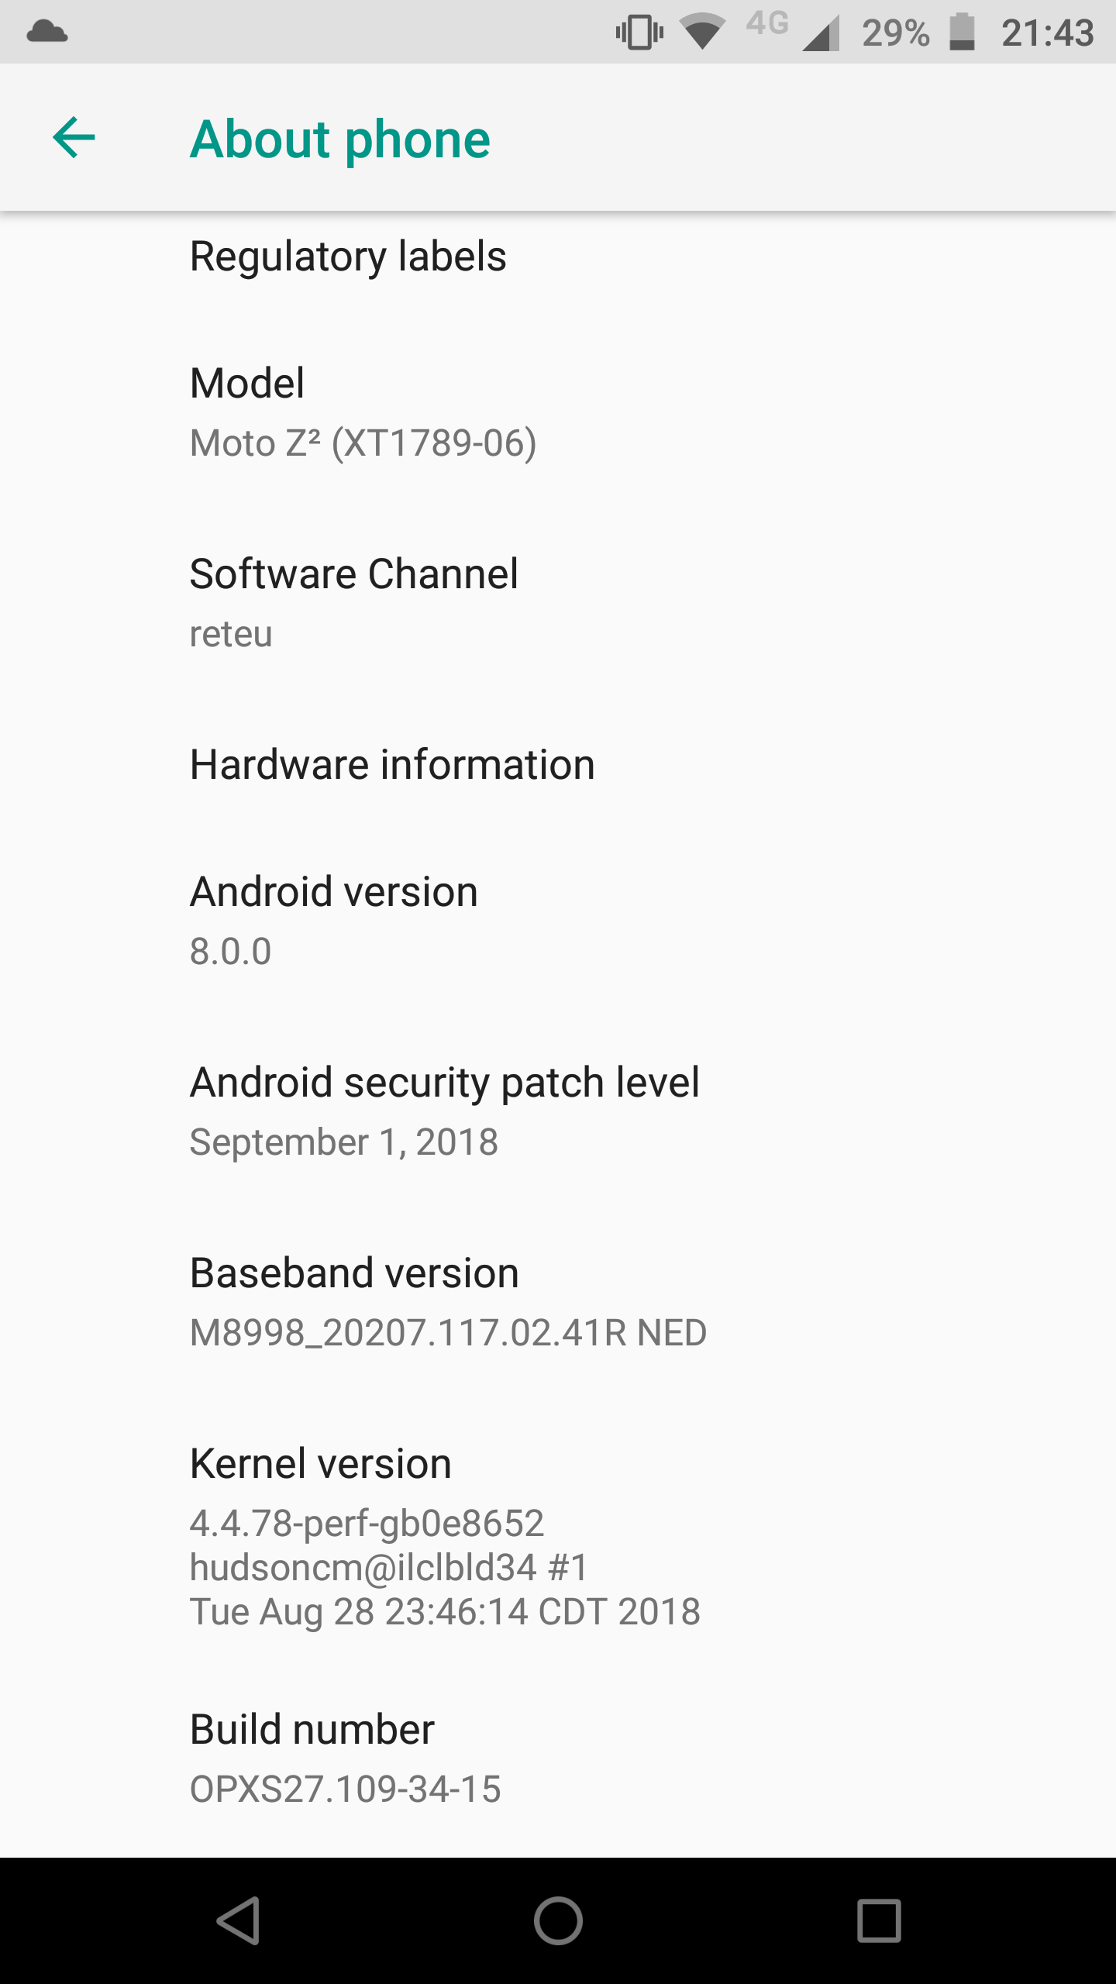

*All tests separated into test suits and split into groups to test categories.*

**b. Functional tests**

**Summary:** Switching between normal and scientific modes

**QA Engineer:** Shevchenko Vadym

**Date:** 26-10-2018

**Test Result:** Passed

**Comments:** Tested switching between modes using screen rotation and on-screen tap

**Summary:** Presence and functionality of all buttons

**QA Engineer:** Shevchenko Vadym

**Date:** 26-10-2018

**Test Result:** Passed

**Comments:**Both normal and scientific modes

**Summary:** Basic arithmetic operations

**QA Engineer:** Shevchenko Vadym

**Date:** 26-10-2018

**Test Result:** Passed

**Comments:** Sum, subtract multiply and divide using integer and decimal numbers. Results must be both signed and unsigned

**Summary:** Advanced operations in scientific mode

**QA Engineer:** Shevchenko Vadym

**Date:** 26-10-2018

**Test Result:** Passed

**Comments:** Both integer and decimal numbers. Results must be both signed and unsigned

**Summary:** Order of arithmetic operations

**QA Engineer:** Shevchenko Vadym

**Date:** 26-10-2018

**Test Result:** Passed

**Comments:** Separate normal, scientific and mixed mode

**Summary:** Number limit of entry and calculations

**QA Engineer:** Shevchenko Vadym

**Date:** 26-10-2018

**Test Result:** Passed

**Comments:** Check how app handles numbers and operations on boundaries of int, long and int64. Both signed and unsigned

**Summary:** Functionality of “backspace”/”reset” button

**QA Engineer:** Shevchenko Vadym

**Date:** 26-10-2018

**Test Result:** Failed

**Comments:** Ability to delete digits one-by-one, whole number and clear screen scenarios.  
!Failed on removing whole number!

**Summary:** Operator overriding

**QA Engineer:** Shevchenko Vadym

**Date:** 26-10-2018

**Test Result:** Passed

**Comments:** Check if pressing two operators are entered one after another, last operator overrides previous

**Summary:** Reaction on two and more simultaneous taps

**QA Engineer:** Shevchenko Vadym

**Date:** 26-10-2018

**Test Result:** Passed

**Comments:** Reaction on two simultaneous taps, releases. Reaction on multitouch

**Summary:** Reaction on long taps

**QA Engineer:** Shevchenko Vadym

**Date:** 26-10-2018

**Test Result:** Passed

**Comments:** Reaction on long taps including multitouch

**Summary:** Checking if entering operators before any numbers not affects calculations

**QA Engineer:** Shevchenko Vadym

**Date:** 26-10-2018

**Test Result:** Passed

**Comments:** As result it must ignore operators in normal mode and show error message in scientific

**c. External factors tests**

**Summary:** Tests for call interruptions

**QA Engineer:** Shevchenko Vadym

**Date:** 26-10-2018

**Test Result:** Passed

**Comments:** Incoming calls with both sides to end up call. Switching to make outgoing call with both sides to end up call

**Summary:** Tests for other interruptions

**QA Engineer:** Shevchenko Vadym

**Date:** 26-10-2018

**Test Result:** Passed

**Comments:** Alarm, calendar, push notifications from other apps

**Summary:** Switching between apps

**QA Engineer:** Shevchenko Vadym

**Date:** 26-10-2018

**Test Result:** Passed

**Comments:** Saving state of app in multitasking mode and working on low memory. How it behaves with video playback in background

**Summary:** Low battery mode

**QA Engineer:** Shevchenko Vadym

**Date:** 26-10-2018

**Test Result:** Passed

**Comments:** Working in normal, low battery modes. Battery consumption

**Summary:** Turning screen on/off, Screen timeout

**QA Engineer:** Shevchenko Vadym

**Date:** 26-10-2018

**Test Result:** Passed

**Comments:** Does it have any influence on app

**Summary:** Connectivity

**QA Engineer:** Shevchenko Vadym

**Date:** 26-10-2018

**Test Result:** Passed

**Comments**: Does it have any influence on app. Bluetooth, nfc, wi-fi , cellular or airplane mode

**Summary:** Working in a split screen mode

**QA Engineer:** Shevchenko Vadym

**Date:** 26-10-2018

**Test Result:** Skipped

**Comments**: Check how two different apps may work in a split screen mode

**Summary:** System and app update

**QA Engineer:** Shevchenko Vadym

**Date:** 26-10-2018

**Test Result:** Skipped

**Comments**: Check for reaction on app autoupdate from Play Store and on system update in background. How it reacts on restart of device

**Summary:** Behavior connected with SD card

**QA Engineer:** Shevchenko Vadym

**Date:** 26-10-2018

**Test Result:** Skipped

**Comments**: How absence or removal (hot and cold) of SD card affects this app

**d. UI/UX testing**

**Summary:** Design accordance to layout

**QA Engineer:** Shevchenko Vadym

**Date:** 26-10-2018

**Test Result:** Passed

**Comments:** Design according to layout and Android ui/ux guides

**Summary:** Reaction on system theme change

**QA Engineer:** Shevchenko Vadym

**Date:** 26-10-2018

**Test Result:** Skipped

**Comments**: Does it affects usability of the app, does font change affect too

**Summary:** Testing menu

**QA Engineer:** Shevchenko Vadym

**Date:** 26-10-2018

**Test Result:** Passed

**Comments**: Menu items according to documentation. Icons and user actions to call menu out

**Summary:** Screen resolution

**QA Engineer:** Shevchenko Vadym

**Date:** 26-10-2018

**Test Result:** Skipped

**Comments**: Behaviour, look and feel of app on resolution of this mobile device. Portrait and Landscape modes

**Summary:** Reaction to hard keys

**QA Engineer:** Shevchenko Vadym

**Date:** 26-10-2018

**Test Result:** Skipped

**Comments**: Volume up, down. Home button. Combinations of them

**Summary:** Reaction on system keyboard shortcuts

**QA Engineer:** Shevchenko Vadym

**Date:** 26-10-2018

**Test Result:** Skipped

**Comments**: How app reacts on shortcuts. Guide - <https://forum.xda-developers.com/showthread.php?t=1672281>

**Summary:** Help file testing

**QA Engineer:** Shevchenko Vadym

**Date:** 26-10-2018

**Test Result:** Skipped

**Comments**: Does it contains all necessary information according to inner documentation and guides

**e. Localization & translation tests**

**Summary:** Menu **t**ranslation & localization

**QA Engineer:** Shevchenko Vadym

**Date:** 26-10-2018

**Test Result:** Skipped

**Comments**: Translation & localization of menu items

**Summary:** Help file translation

**QA Engineer:** Shevchenko Vadym

**Date:** 26-10-2018

**Test Result:** Skipped

**Comments**: Translation of help file

**Summary:** Feedbacktranslation

**QA Engineer:** Shevchenko Vadym

**Date:** 26-10-2018

**Test Result:** Skipped

**Comments**: Translation of feedback window

**Summary:** Error messages **t**ranslation

**QA Engineer:** Shevchenko Vadym

**Date:** 26-10-2018

**Test Result:** Skipped

**Comments**: Translation & localization of error messages

**Summary:** Date localization

**QA Engineer:** Shevchenko Vadym

**Date:** 26-10-2018

**Test Result:** Passed

**Comments**: Date localization for History section

**f. Performance tests**

**Summary:** App loading time tests

**QA Engineer:** Shevchenko Vadym

**Date:** 26-10-2018

**Test Result:** Passed

**Comments**: App should load in <=2 seconds in 50% of cases with different states of memory load

**Summary:** Switching between screens and app modes

**QA Engineer:** Shevchenko Vadym

**Date:** 26-10-2018

**Test Result:** Passed

**Comments**: How long takes to open menu, help, feedback screen, reaction to screen rotation and mode switching. Time can be tracked by recording app into video and calculate time in frames in video editor

**Summary:** Timing tests

**QA Engineer:** Shevchenko Vadym

**Date:** 26-10-2018

**Test Result:** Skipped

**Comments**: How long takes for an app to react on button taps and to perform calculations. Time can be tracked by recording app into video and calculate time in frames in video editor

**Summary:** Loading large ammounts of data

**QA Engineer:** Shevchenko Vadym

**Date:** 26-10-2018

**Test Result:** Skipped

**Comments**: Performing same operations with large amounts of data and repeating operations. Using numbers on limits of int, long and int64

**Summary:** Long time running

**QA Engineer:** Shevchenko Vadym

**Date:** 26-10-2018

**Test Result:** Skipped

**Comments**: Performing interaction with app for a long time and leaving it in idle state

**Summary:** Random screen taps and keystrokes

**QA Engineer:** Shevchenko Vadym

**Date:** 26-10-2018

**Test Result:** Skipped

**Comments**: Performing random interactions on app with different speed

**Summary:** Repeatedly opening and closing application

**QA Engineer:** Shevchenko Vadym

**Date:** 26-10-2018

**Test Result:** Skipped

**Comments**: Open and close app for a big amount of times

**3. TEST RESULTS & ASSESTMENTS**

**a. Results summary**

**Test suits performed:** 22

**Test suits passed:** 17

**Test suits successfully passed:** 21

**Test suits failed:** 1

**Bugs severity**:

Critical – 0, Major – 0, Minor – 1, Trivial – 0.

**b. Assestments**

As tested software was already released and QA engineer had a little time to perform tests, test suits were not covering all aspects of functional and non-functional test and quite a big amount of test cases were either not covered or skipped. Most attention was paid to functional tests as it is vital to check functional readiness and functional tests have highest priority in term of lack of time for tests.   
Software is already released and has high level of functional readiness. Most of functional tests were passed, basic checks for usability, performance, localization and interruptions were also passed successfully. Failed test may be interpreted more as feature to be improved but the last decision of it’s priority must be made by QA Lead & management.

It needs to be mentioned that performance and localization tests in most part were skipped and it may affect on final quality of a product and this tests must be performed on next iteration thoroughly.

Also test were performed only on single device without using either emulators or other hardware devices. This means that we cannot guarantee reliable work of app on other devices. In next iterations we need to diverse tests into different devices and emulators but hardware devices must have priority as emulator behavior can differ from the one on actual device. Besides some activities (e.g. photos, switching connections) cannot be realistically emulated.

Also we additionally need take in consideration how this version of app will work on other versions of OS. Latest reports show that near 7% of users are still using OS version 4.4. App was tested on a device with OS version 8.0 but it’s not included in top 3 of currently used OS versions so test plan for next iteration needs to cover devices with these operation systems.

**4. CONCLUSION**

Thank you for reading this report. Tested software has quite a high quality at first sight but we need to make additional tests in future to be sure it is a solid and stable product. Additional tests still has to be performed and they have to pay more attention on performance, UI part and functional part must be tested during regressions. Also it has a room for improvements.